NOMURA KakushIN 2026
Financial Literacy & Agentic AI Hackathon

VAAKYA
वाक्य

Financial Guardians — AI Agents for Financial Empowerment
VAAKYA is a multi-agent financial companion that proactively educates, protects, plans, and connects users throughout their financial journey.

Team Invincibles
Sanket Mali · Pinak Salunke SVKM's NMIMS MPSTME
B.Tech Computer Science
Submission Round 1 — Executive Summary June 2026
File Name SVKM's NMIMS MPSTME_INVINCIBLES_PINAK_SANKET_Executive Summary

Table of Contents

Executive Summary 3
- Problem Understanding 3
- Proposed Solution — VAAKYA 3
2.1 The Four-Agent Architecture 3
2.2 Serving All Four Personas 3
2.3 Key Innovations 3
- Technology Stack 3
About Us 3
Appendix 3
Appendix A — Agent Interaction Model 3
Appendix B — Why VAAKYA vs. a Generic Financial Chatbot 3

Executive Summary

1. Problem Understanding

Brief Understanding of the Problem Statement

Our analysis of the four personas—Priya, Rajesh, Kisan, and Divya—revealed a common pattern that goes beyond financial literacy.

India has made remarkable progress in financial inclusion. Digital payments, online banking, investment platforms, insurance products, and government welfare schemes are now more accessible than ever before. However, increased access has created a new challenge: individuals are expected to make increasingly complex financial decisions without having access to personalized guidance.

This creates a paradox. Financial services are becoming smarter, but financial decision-making remains difficult.

Priya can access hundreds of investment products but struggles to determine which one aligns with her goals. Rajesh earns through the digital economy yet lacks guidance for managing irregular income and building financial resilience. Kisan may be eligible for multiple government benefits but often faces information overload, accessibility barriers, and procedural complexity. Divya has access to financial services but not always in formats that support independent and inclusive participation.

Although their circumstances differ, all four personas encounter the same challenge at critical moments of decision-making: evaluating opportunities, assessing risks, understanding consequences, and taking informed action.

This led us to a key insight:

India's next financial inclusion challenge is not access to financial services—it is access to financial confidence.Current solutions largely focus on delivering information. However, information alone does not create confidence. Users need support that understands their context, adapts to their needs, communicates in their language, protects them from financial risks, and guides them toward better decisions over time.Therefore, the opportunity is not to build another financial chatbot, but to create an intelligent financial companion that continuously educates, protects, and empowers individuals throughout their financial journey while helping them build measurable financial confidence.

2. Proposed Solution — VAAKYA

2.1 The Four-Agent Architecture
"VAAKYA is a multi-agent financial companion that proactively educates, protects, plans, and connects users throughout their financial journey."
VAAKYA is an AI-powered financial inclusion platform that combines Agentic AI, Financial Knowledge Retrieval, Accessibility-First Design, Scam Prevention, and Personalized Financial Planning into a unified ecosystem.
At the core of VAAKYA lies a Financial Life Graph, a dynamic representation of each user's financial profile, goals, learning progress, risk exposure, scheme eligibility, and financial behavior. This enables the system to provide personalized guidance instead of generic responses.
Multi-Agent Architecture
1)Educator Agent
Provides personalized financial literacy, investment education, and simplified explanations using trusted financial knowledge sources.

2)Strategy Builder Agent
Creates customized financial roadmaps, savings plans, and goal-oriented strategies based on the user's financial profile and aspirations.
3)Sentinel Agent
Protects users from scams, fraudulent investment schemes, and predatory loan applications through intelligent risk analysis.
4)Connector Agent
Identifies relevant government schemes, evaluates eligibility, estimates potential benefits, and guides users through the application process.
2.2 Serving All Four Personas
Priya · Thane | Rajesh · Mumbai | Kisan · Karnataka | Divya · Pune
Gains confidence to evaluate investment and insurance products before making financial commitments. | Builds long-term savings discipline and financial resilience despite variable income. | Builds long-term savings discipline and financial resilience despite variable income. | Receives fully accessible financial guidance and personalized benefit discovery without accessibility barriers.

2.3 Key Innovations
- Dual-LLM architecture: sensitive data stays on-device while complex reasoning is handled by the cloud AI.
- Financial Life Graph for deep personalization and contextual understanding.
- Multi-Agent AI Architecture enabling specialized financial assistance instead of a generic chatbot experience.
- Financial Confidence Score that measures financial literacy, savings behavior, scam awareness, and goal progression.
- Accessibility-First Design supporting voice-based interaction for visually impaired and low-literacy users.
- Scam Prevention System capable of analyzing suspicious messages, advertisements, and loan offers.
- Government Scheme Discovery Engine connecting users with relevant public welfare programs.
- Behavioral Impact Measurement focusing on real financial outcomes rather than engagement metrics.
3. Technology Stack
All libraries, databases, middleware, and infrastructure components listed with exact versions as required for environment setup on the competition day:
Layer | Technology & Exact Version
Frontend | Next.js 14.2.30 · TypeScript 5.5.4 · Tailwind CSS 3.4.4 · ShadCN UI · PWA
Backend | FastAPI 0.111.1 · Python 3.12.4
AI & Agents | Gemini 2.5 Pro · LangGraph 0.2.x
Knowledge & Retrieval | Qdrant 1.10.1 · LlamaIndex 0.11.7 · multilingual-e5-large
Data Layer | Cloud Firestore · Neo4j Community 5.23 · Firebase Storage
Voice & Accessibility | Whisper Large-v3 · Coqui TTS 0.22 · IndicTrans2 1.1
Document Intelligence | PaddleOCR 2.7.3
Authentication | Firebase Authentication
Deployment & Infrastructure | Docker 26.1.x · AWS ECS Fargate · AWS Application Load Balancer (ALB) · AWS CloudFront · AWS CloudWatch · AWS IAM

VAAKYA is built on a single conviction: financial intelligence should not be a privilege.
It should be a right — available in every language, every village, every pocket, at every hour.

About Us

Team Member 1
Full Name | Sanket Mali
Institution | SVKM's NMIMS MPSTME, Shirpur
Programme | B.Tech Computer Science (Batch 2023–2027)
Certifications | AWS Certified Cloud Practitioner · AWS Solutions Architect Associate
Publication | IEEE DELCON 2025 — Published research paper on Intelligent Transportation Systems (Spatio-temporal Modelling & Traffic Forecasting)
Technical Skills | Next.js · Tailwind CSS · ShadCN UI · Firebase Authentication · Firestore · Firebase Storage · Whisper · Coqui TTS · PaddleOCR · Progressive Web Applications (PWA) · Frontend Development · API Integration
Key Projects | Smart Campus Biometric Access Control System (MERN + Docker + AWS + eSSL X990) · SentinelX Crisis Response Platform (GDG — MERN + Gemini + Firebase) · VAAKYA Multi-Agent Financial Guardian
Role in VAAKYA | Responsible for frontend development, accessibility-first user experience, voice interaction pipeline (Whisper + Coqui TTS), Firebase integration, OCR workflow integration, responsive PWA implementation, and user-facing platform design.

Team Member 2
Full Name | Pinak Salunke
Institution | SVKM's NMIMS MPSTME, Shirpur
Programme | B.Tech Computer Science (Batch 2023–2027)
Certifications | AWS Cloud Practitioner
Publication | IEEE REACS 2025 - Performance Analysis of a Generalized Card Trick Algorithm: A Case Study in Algorithmic Optimization.
Technical Skills | Python · FastAPI · LangGraph · Gemini AI · Neo4j · Qdrant · LlamaIndex · Agentic AI Systems · RAG Architecture · Docker · AWS Cloud Infrastructure · System Design
Key Projects | Visual SQL Query Builder and Executor (React.js, Flask, SQLite)
Role in VAAKYA | Responsible for multi-agent orchestration using LangGraph, Financial Life Graph design (Neo4j), RAG pipeline (Qdrant + LlamaIndex), Gemini integration, backend development using FastAPI, and overall system architecture

Appendix

Appendix A — Agent Interaction Model
The following describes how the four VAAKYA agents collaborate:
User sends input (text/voice/image) | Users interact with VAAKYA through text queries, voice commands, or image uploads (e.g., scam screenshots, financial documents).
Educator Agent (Reactive) | Retrieves relevant financial knowledge using LlamaIndex + Qdrant RAG pipeline and generates personalized explanations through Gemini 2.5 Pro.
Strategy Builder Agent (Proactive + Reactive) | Uses Financial Life Graph data from Neo4j to generate customized savings plans, financial roadmaps, and goal-oriented strategies.
Sentinel Agent (Reactive) | Processes uploaded screenshots using PaddleOCR and Gemini 2.5 Pro to detect scams, fraudulent offers, and predatory loan applications.
Connector Agent (Reactive) | Matches user attributes with government schemes and benefits using Neo4j profile data and scheme knowledge stored in Qdrant.
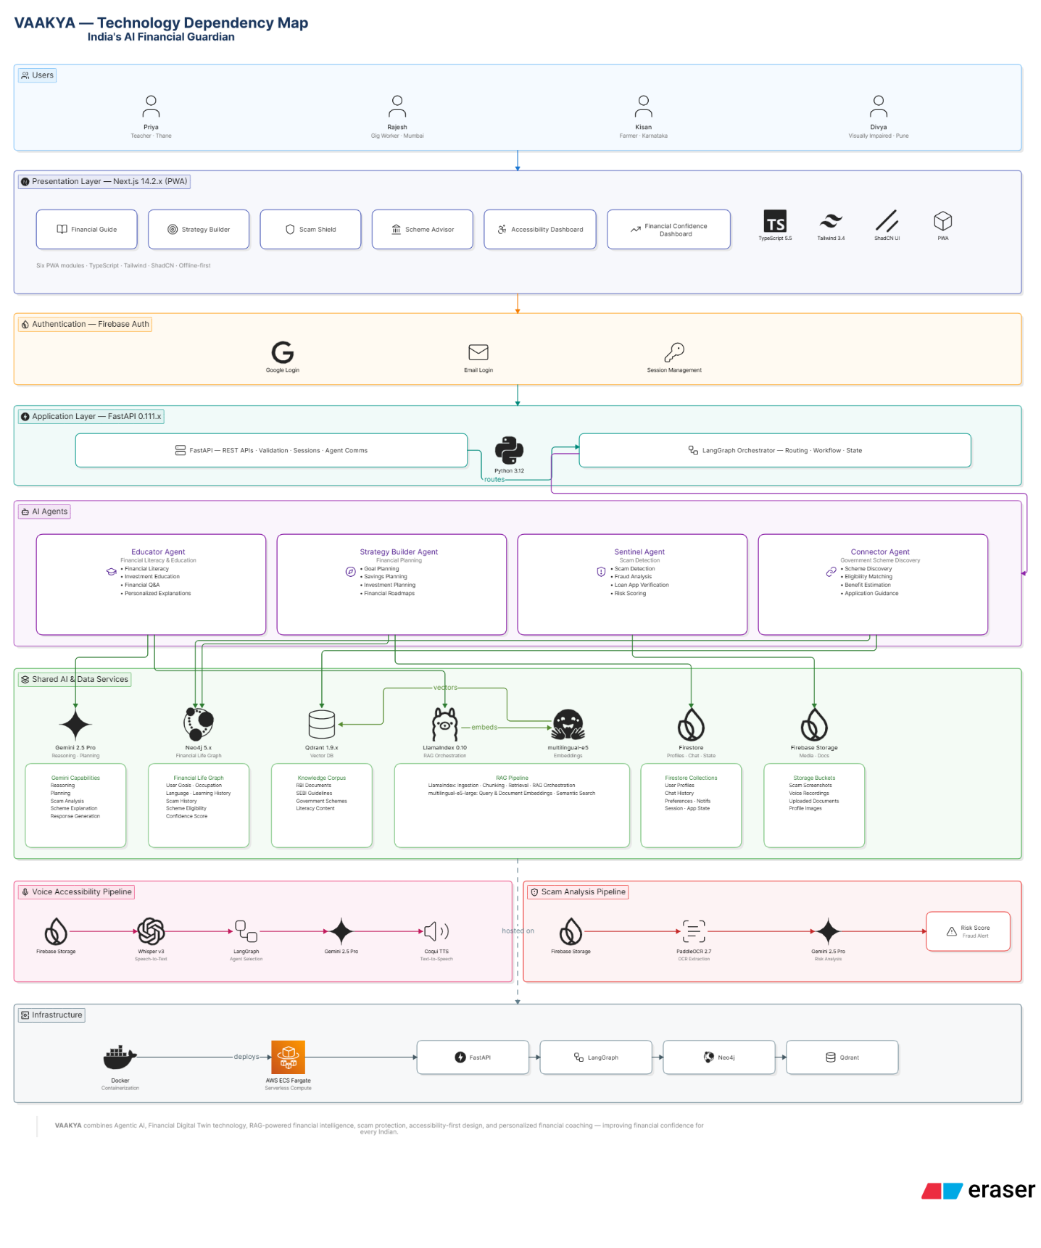

Appendix B — Why VAAKYA vs. a Generic Financial Chatbot

VAAKYA vs. a Generic Financial Chatbot
Dimension | Generic Chatbot | VAAKYA
AI Architecture | Single LLM in a loop | 4-agent constellation + Financial Life Graph
Intervention Mode | Reactive (user must ask) | Proactive (Guardian monitors & nudges)
Personalization | Prompt-based context injection | Evolving personal knowledge graph (Neo4j)
Fraud Protection | None | Real-time SENTINEL scam detection pipeline
Accessibility | Multilingual text | Voice-first, IVR, screen-reader native, offline packs
Impact Tracking | Session count / DAU | Verified ₹ behavioral change (3-tier framework)
Gov. Schemes | Generic FAQ | Eligibility engine with step-by-step application guide


